Ex1

Modify the HelloWorld program to print the current date and time

Ex2

I expect that the values would be:

* 1
* 2
* 3
* 1

Result:

In debugger, when expanding the variable a, it will loop values in variable a,b,c as they reference each other.

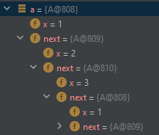

Ex3

  
